**March 6, 2015**

March already. This year has flown by. I am hard at work editing Before, the sequel/prequel to After.

Before is set in the present and features Jack and Danny from After.

Their story begins when Jack gets sent an email from an old college friend containing a file about a deadly virus.

Danny is on the same train as her friend and is injected with the antivirus as he gets off at his stop.

The virus is released on the train and 37 people are infected. The bodies are removed and sent to the small town of Trinity for further study.

Jack and Danny travel there in a bid to get evidence they can use against Gene Pharm so they can keep themselves safe.

Unfortunately the infected escape and the zombie plague begins.



**Reviews**

I offer free reviews to authors via my website:

[www.storyteller-skgregory.weebly.com](http://www.storyteller-skgregory.weebly.com).

I prefer horror, sci-fi, action and thrillers although I will consider other genres.

You can contact me using the contact sheet on the site.

You can also follow my blog through Networked Blogs and you can follow me on Goodreads at:

<https://www.goodreads.com/author/show/6574558.S_K_Gregory>

I am now offering copy editing and proofreading through the site too.

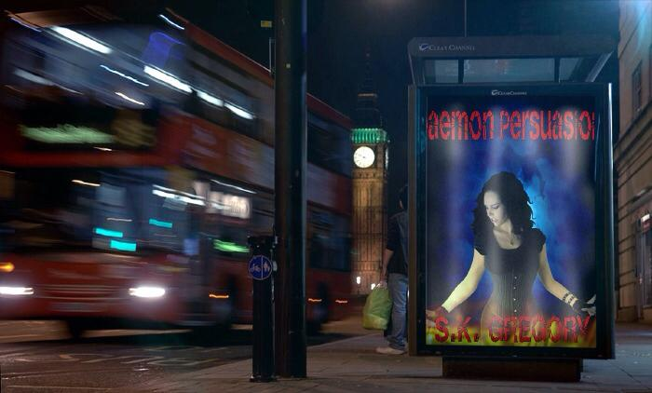

Book Review of the Month

I have reviewed quite a few books in the past month and have decided to promote my favorite in my newsletter.

The book I have chosen is:

Aurora Sky: Vampire Hunter



|  |  |
| --- | --- |
|  |  |

If there is one thing eighteen-year-old Aurora Sky wants, it's to get off the iceberg she calls home. Being kissed before she graduates wouldn't hurt either.   
  
Then a near-fatal car wreck changes everything. Government agents step in and save Aurora's life in exchange for her services as a vampire hunter. In Alaska. Basically she's a glorified chew toy. All thanks to her rare blood type, which sends a vampire into temporary paralysis right before she has to finish the job... by hand.   
  
Now Aurora's only friends are groupies of the undead and the only boy she can think about may very well be a vampire.

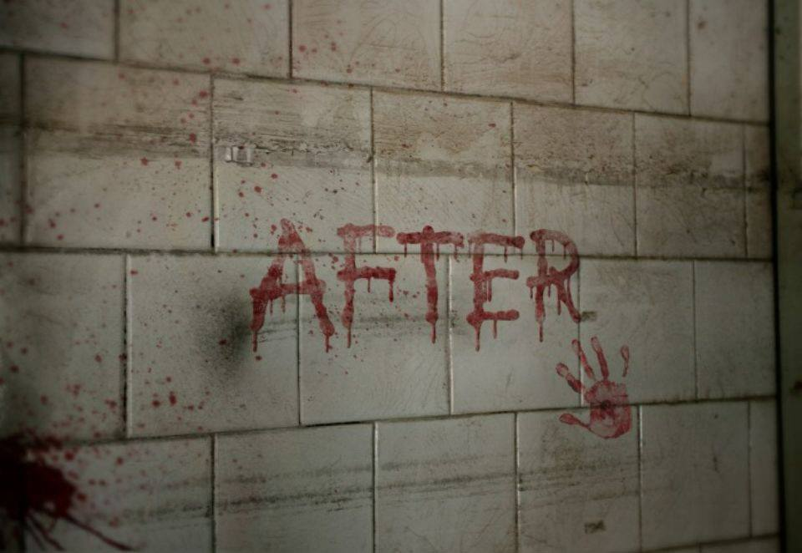

**COntact me:**

Facebook: <https://www.facebook.com/daemonpersuasion>

Twitter:

<https://twitter.com/sam_skgregory>

Goodreads: <https://www.goodreads.com/author/show/6574558.S_K_Gregory>

Email: [skgregory@hotmail.com](mailto:skgregory@hotmail.com)

All of my books are available from Amazon.