**May 8, 2015**

**Special Promo offer for Authors**

I am running a special promo offer for authors. For only $5.00 I can offer the following:

* A tweet once a day for a week including a link to your website to over 13k followers
* A post on my blog
* A post on Facebook, everyday for a week including several book groups I am a member of with over 40K followers
* A post on my Tumblr blog
* A simple yet effective banner that I will create and send to you in JPEG format
* A review on Amazon or equivalent
* A review on Goodreads and recommendations to my followers for your book

Contact me through the contact page on my site at:

http://storyteller-skgregory.weebly.com/promo-offer.html



It’s been a busy week. A royal baby, the general election and Blood Moon Rising kicked off with some great authors.

Toneye Eyenot opened the show with a look inside his twisted mind and everything horror.

The event will run throughout the month so please join us if you love horror, fantasy and sci-fi. There’s something for everything here.

You can join the event here:

<https://www.facebook.com/events/920306537989500/>

Author List:

Toneye Eyenot - 2nd and 3rd  
Andy Bove - 4th and 5th  
Shellie Blum - 6th and 7th  
Shaun Meeks - 8th and 9th  
Catt Dahman - 10th and 11th  
Michael Noe - 12th and 13th  
Sam Gregory - 14th and 27th  
Adam Baxter (writing as Ash Hartwell) - 15th and 26th  
Richard D Ramsey - 16th and 17th  
Christina Engela - 18th and 19th  
Mark Woods - 20th and 21st  
Scott Essel Pratt - 22nd and 23rd  
Anthony Crowley - 24th and 25th  
Kat Gracey - 28th and 29th  
Michael Carson - 30th and 31st

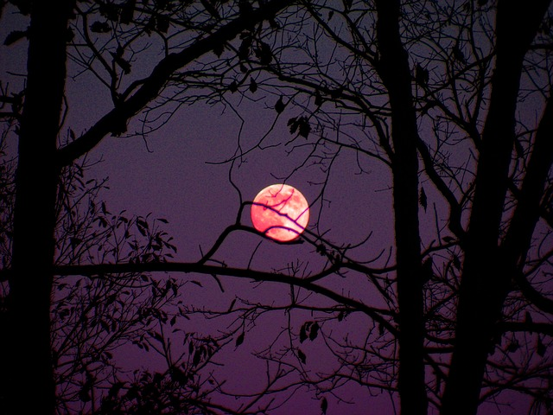

Coming this June – Summer of Zombies 2015 hosted by Armand Rosmilia.

I will be one of the authors attending the event and it features anything zombie.

I hope you will stop by. Feel free to ask me questions and get engaged with the other great authors who are participating in this event.

<https://www.facebook.com/events/105240559807325/>





**COntact me:**

Facebook: <https://www.facebook.com/daemonpersuasion>

Twitter:

<https://twitter.com/sam_skgregory>

Goodreads: <https://www.goodreads.com/author/show/6574558.S_K_Gregory>

Email: [skgregory@hotmail.com](mailto:skgregory@hotmail.com)

All of my books are available from Amazon.