**June 10, 2015**

**Special Promo offer for Authors**

I am running a special promo offer for authors. For only $5.00 I can offer the following:

* A tweet once a day for a week including a link to your website to over 13k followers
* A post on my blog
* A post on Facebook, everyday for a week including several book groups I am a member of with over 40K followers
* A post on my Tumblr blog
* A simple yet effective banner that I will create and send to you in JPEG format
* A review on Amazon or equivalent
* A review on Goodreads and recommendations to my followers for your book

Contact me through the contact page on my site at:

http://storyteller-skgregory.weebly.com/promo-offer.html



Blood Moon Rising is finished. The event was a lot of fun and some amazing authors took part. We only lost two throughout the month (but don't worry we’re still looking for them! Lol)

The event was designed to showcase the talent of lesser known authors and give them a chance to connect with their audience.

I will be running a second event in October and I am taking names for that now.

I hope to get 30 authors approx.

If you are interested feel free to contact me. You must be a published or self published author in the following genres: horror, sci-fi or fantasy.

You can email me at [skgregory@hotmail.com](mailto:skgregory@hotmail.com)



SKGREGORY

Coming this June – Summer of Zombies 2015 hosted by Armand Rosmilia.

I will be one of the authors attending thit features anything zombie.

I hope you will stop by. Feel free to ask me questions and get engaged with the other great authors who are participating in this event.

<https://www.facebook.com/events/105240559807325/>

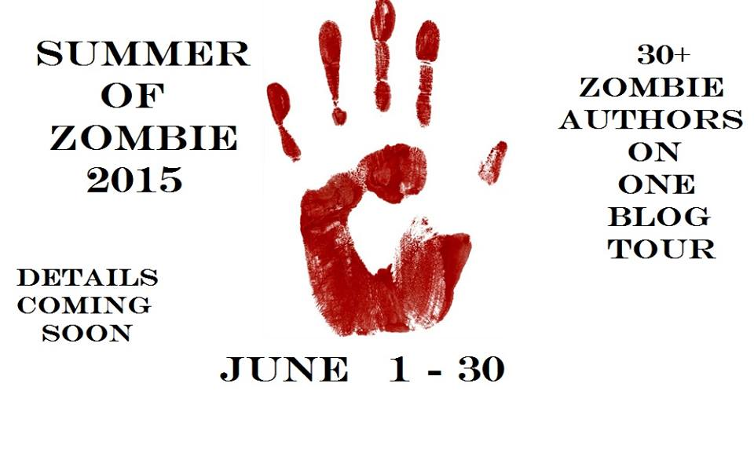

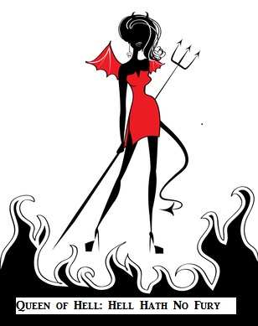

**COntact me:**

Facebook: <https://www.facebook.com/daemonpersuasion>

Twitter:

<https://twitter.com/sam_skgregory>

Goodreads: <https://www.goodreads.com/author/show/6574558.S_K_Gregory>

Email: [skgregory@hotmail.com](mailto:skgregory@hotmail.com)

All of my books are available from Amazon.