**July 9, 2015**

**Special Promo offer for Authors**

I am running a special promo offer for authors. For only $5.00 I can offer the following:

* A tweet once a day for a week including a link to your website to over 13k followers
* A post on my blog
* A post on Facebook, every day for a week including several book groups I am a member of with over 40K followers
* A post on my Tumblr blog
* A simple yet effective banner that I will create and send to you in JPEG format
* A review on Amazon or equivalent
* A review on Goodreads and recommendations to my followers for your book

You can run the campaign for two weeks for 7.50

Contact me through the contact page on my site at:

http://storyteller-skgregory.weebly.com/promo-offer.html



New Release – Indeadpendence Day

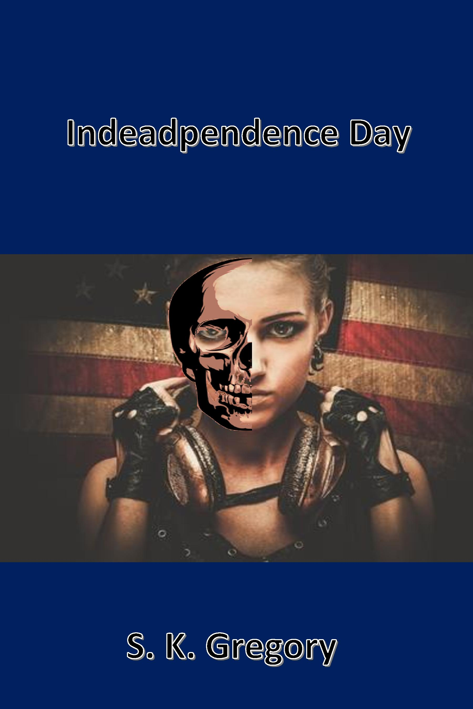

Indeadpendence Day is my new zombie novella which is available to buy from Amazon.

July 4th

The infection begins.

Rachel and her family end up in a small town when it is overrun by zombies. The infection spreads quickly and Rachel fights to keep herself and her little cousin alive.

Teaming up with two soldiers, Gabe and Adam, they must try and escape the town before it is blown off the map.

But will it be enough to stop the zombies?

SKGREGORY

Book Covers for Kindle

I am now selling book covers for Kindle through my site.



I will be adding more over time. If you are interested in purchasing one or having one created for you then please contact me via email.

The file will be sent as a jpg with your title and author name added to it.

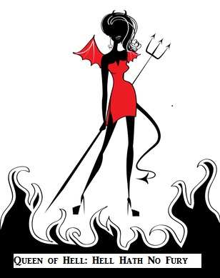

**COntact me:**

Facebook: <https://www.facebook.com/daemonpersuasion>

Twitter:

<https://twitter.com/sam_skgregory>

Goodreads: <https://www.goodreads.com/author/show/6574558.S_K_Gregory>

Email: [skgregory@hotmail.com](mailto:skgregory@hotmail.com)

All of my books are available from Amazon.