**February 9, 2015**

It’s February and it’s going to be a busy month. I will be holding a giveaway on Goodreads for a signed copy of After and working on the sequel.

Daemon Madness is at the publishers and here is a sneak peek at it:

*England 1887*

*Drawing his cloak around him tightly, Jeremiah Fleming walked along the dirt road at dusk, as he had been instructed to do. The map he had been given was old and the markings on it were faded, making it almost impossible to know if he was heading in the right direction. He had been told to go alone and he had agreed at the time but now he wondered if he was walking into a trap. He was after all, a prominent figure, making him a good target for kidnapping.*

*The demon he was being sent to find wasn’t recorded in the journals. He was elusive and did not always reside in this plane. Tonight was one of the rare nights that he could be summoned and a deal could be struck.*

*Since being initiated the year before, Jeremiah had been pushing for this to happen. The old order had all died out and as the new leader he had complete control. There were always going to be naysayer’s but he would deal with them in time.*

*He came to the crossroads by the old oak and stopped. This was the spot.*

*Making sure he had his knife within reach, he settled under the tree to wait. It grew dark before long, the silence was interrupted occasionally by the call of an owl but otherwise it all remained still. After the long walk Jeremiah was tired and after a while he began to doze.*

*A shrill scream roused him. It did not sound human, more animal. He climbed to his feet with his knife at the ready. A thin mist had rolled in.*

*“That knife won’t harm me,” a voice said.*

*Jeremiah turned to find a cloaked figure behind him. A cold chill ran along his spine. He knew he was in the presence of real evil.*

*“I’ve come to make a deal,” he said.*

**Reviews**

I offer free reviews to authors via my website:

[www.storyteller-skgregory.weebly.com](http://www.storyteller-skgregory.weebly.com).

I prefer horror, sci-fi, action and thrillers although I will consider other genres.

You can contact me using the contact sheet on the site.

You can also follow my blog through Networked Blogs and you can follow me on Goodreads at:

<https://www.goodreads.com/author/show/6574558.S_K_Gregory>

I am now offering copy editing and proofreading through the site too.



*The traveler gave a low chuckle, “Such a righteous man wants to make a deal with me? What could you possibly want?”  
“Power. The kind only you can provide.”  
“Many humans have come before, asking for the same thing. Why should I grant it to you?”*

*“The others weren’t worthy. I am,” he said with more confidence than he felt. He knew that showing fear would be a mistake.*

*The traveler moved closer, almost seeming to glide across the ground. Jeremiah stood firm, although the thought of this thing touching him made him nauseous.*

*From the blackness under its hood Jeremiah swore he saw two red eyes staring back at him. When he blinked though, they had disappeared.*

*The traveler held out a hand. The skin was dark red in color and the fingers ended in pointed black claws. Jeremiah realized he wanted his hand. He reluctantly gave it to him.*

*One of the claws snaked out and pierced the palm of his hand. Jeremiah hissed, more in surprise than pain.*

*He bent his head over the wound. At first Jeremiah thought the traveler was smelling his blood, then he realized he was drinking it.*

*He jerked his hand away on instinct but the grip around his wrist was like iron. That made him think of the knife. He raised it but suddenly it seared his hand. He dropped it onto the ground.*

*The traveler raised his head, “Your blood is tainted. You have killed for your own gain, betrayed those who are loyal to you and will do anything for power. You are worthy.”  
Jeremiah smiled, “So you will help me?”*

*“I will. You are aware of the sacrifice required?”*

*“I am. Do I need to sign a contract?”*

*“That won’t be necessary. The agreement is already made. You will need these ingredients,” he handed him a piece of parchment.*

*“You will need seven for the sacrifice.”*

*“Seven? I only have four.”*

*“Seven are required. Do what is necessary to complete the ritual.”  
The traveler turned away.*

*“Wait. Do they have to be willing?”*

*“It’s not a requirement.”*

*“Good. It will be done.”*

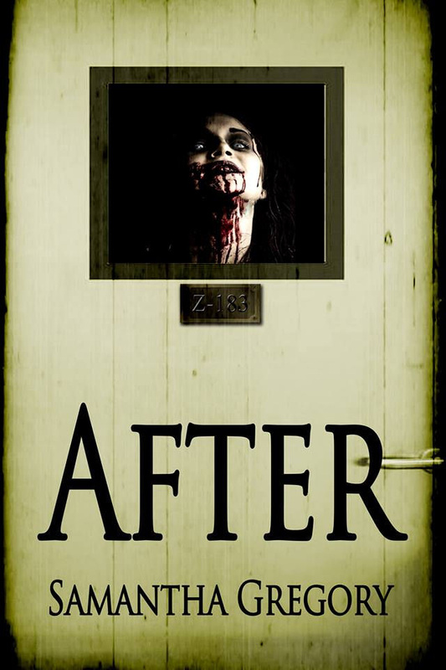

**COntact me:**

Facebook: <https://www.facebook.com/daemonpersuasion>

Twitter:

<https://twitter.com/sam_skgregory>

Goodreads: <https://www.goodreads.com/author/show/6574558.S_K_Gregory>

Email: [skgregory@hotmail.com](mailto:skgregory@hotmail.com)

All of my books are available from Amazon.