**April 6, 2015**

**Special Promo offer for Authors**

I am running a special promo offer for authors. For only $5.00 I can offer the following:

* A tweet once a day for a week including a link to your website to over 13k followers
* A post on my blog
* A post on Facebook, everyday for a week including several book groups I am a member of with over 40K followers
* A post on my Tumblr blog
* A simple yet effective banner that I will create and send to you in JPEG format
* A review on Amazon or equivalent
* A review on Goodreads and recommendations to my followers for your book

Contact me through the contact page on my site at:

http://storyteller-skgregory.weebly.com/promo-offer.html



I have just returned my Queen of Hell: Hell Hath No Fury edits to JEA Press and I am planning a big launch for the book when it is released.

Queen of Hell features Sasha, a succubus who is destined to become the Queen of a hell dimension when she turns 20.

Sasha doesn’t want to be Queen however, so her sister Sarah plots to steal the crown from her.

Sarah performs a spell to take it and sacrifices three losers at her college. The problem is they don’t stay dead.

Trace comes back as a ghost, Dale a zombie and Jesse is revived by Sasha. As they try to stop Sarah from completing the ritual, Sasha discovers that she can alter her destiny and take back her life.

This is the first book in a new series and I am already working on the sequel – Hellbound.

Before is completed! I will be editing it over the next few weeks and then it will be submitted to JEA.

Daemon Madness is also at the editing stage. It is going to be a busy year for releases.

Blood Moon Rising

For the month of May I will be hosting a FB event for horror, fantasy and sci-fi authors.

The event will help promote the authors and provide an insight into the books they write. It is going to be a fun event and everyone is welcome to attend.

We have fifteen authors each with two days to take over the event and post what they want. There will be interviews, stories, giveaways and tips for new writers.

You can join the event here:

<https://www.facebook.com/events/920306537989500/>

Author List:

Toneye Eyenot - 2nd and 3rd  
Andy Bove - 4th and 5th  
Shellie Blum - 6th and 7th  
Shaun Meeks - 8th and 9th  
Catt Dahman - 10th and 11th  
Michael Noe - 12th and 13th  
Sam Gregory - 14th and 27th  
Adam Baxter (writing as Ash Hartwell) - 15th and 26th  
Richard D Ramsey - 16th and 17th  
Christina Engela - 18th and 19th  
Mark Woods - 20th and 21st  
Scott Essel Pratt - 22nd and 23rd  
Anthony Crowley - 24th and 25th  
Kat Gracey - 28th and 29th  
Michael Carson - 30th and 31st



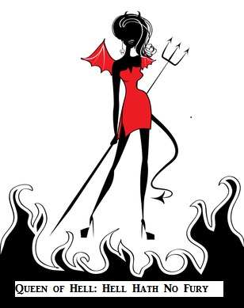

**COntact me:**

Facebook: <https://www.facebook.com/daemonpersuasion>

Twitter:

<https://twitter.com/sam_skgregory>

Goodreads: <https://www.goodreads.com/author/show/6574558.S_K_Gregory>

Email: [skgregory@hotmail.com](mailto:skgregory@hotmail.com)

All of my books are available from Amazon.